Android Email Password Change Instructions
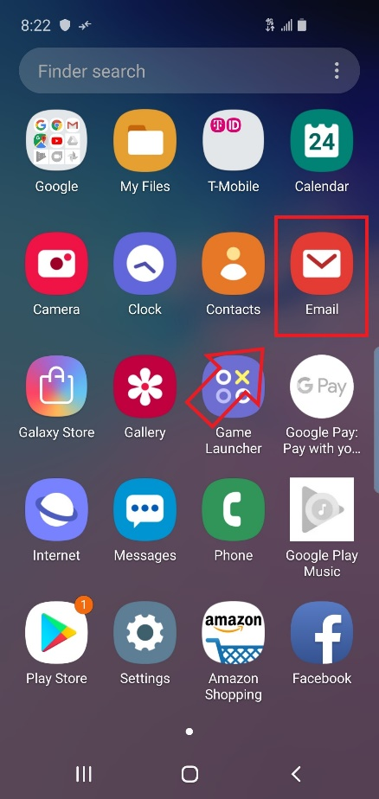
- Find the Email app on your phone.

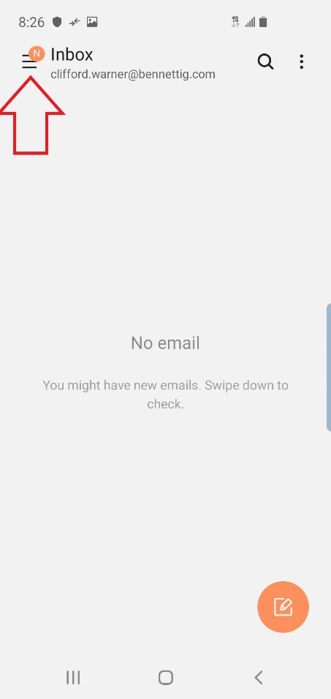
- You should see Three Lines. Tap those Three Lines, and a menu should pop up on the left of the screen.

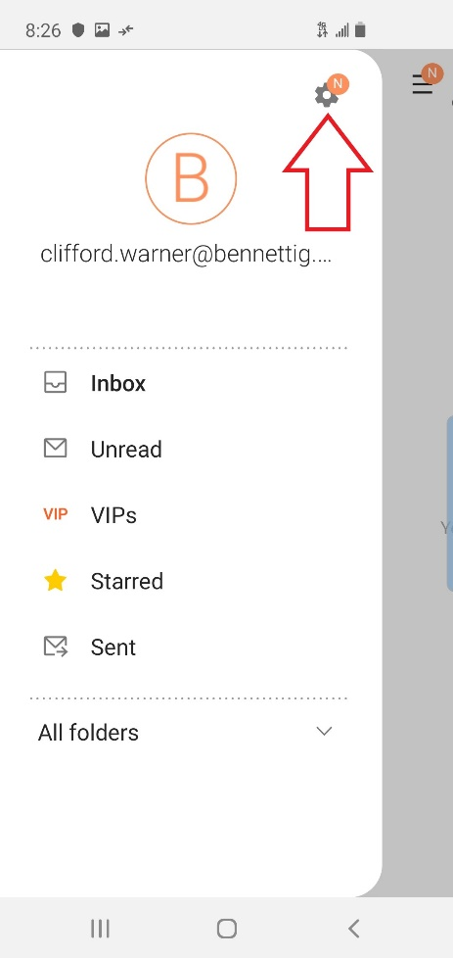
- On that menu, tap the Gear icon on the top right.

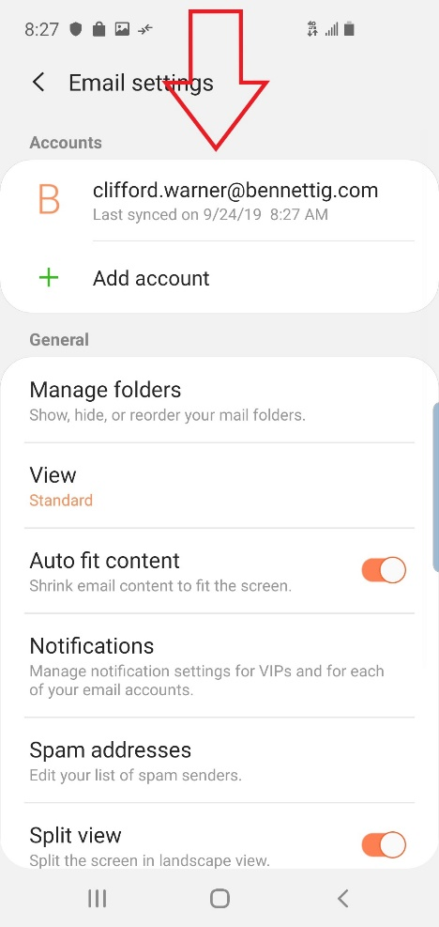
- Under the spot where it says Accounts, tap your Bennett email address.

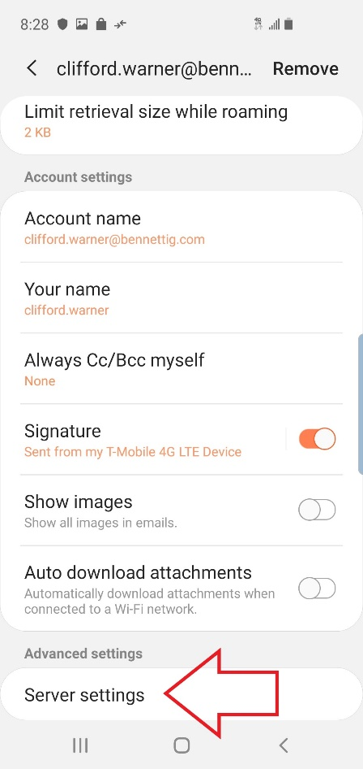
- Scroll down to the bottom of the screen that pops up, and tap on Server Settings.

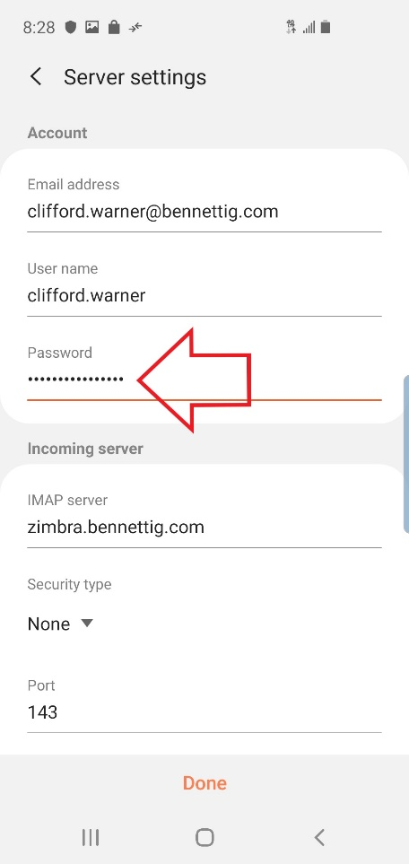

- In the first Password slot (under the Account section), type in your new password.

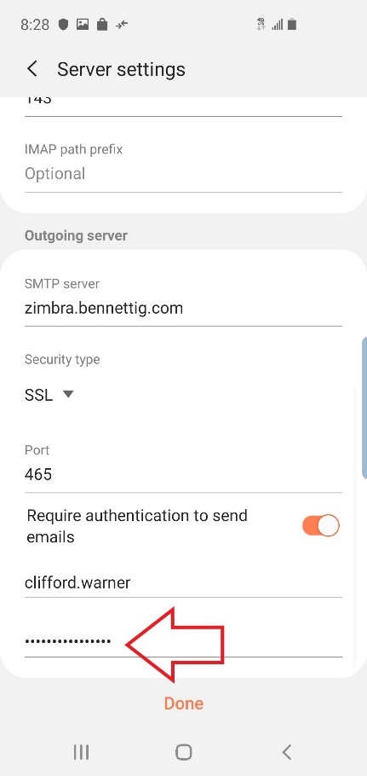
- Now, scroll down to the bottom to where you see Outgoing server.
- You will see another slot with a bunch of dots. Enter in your password there.

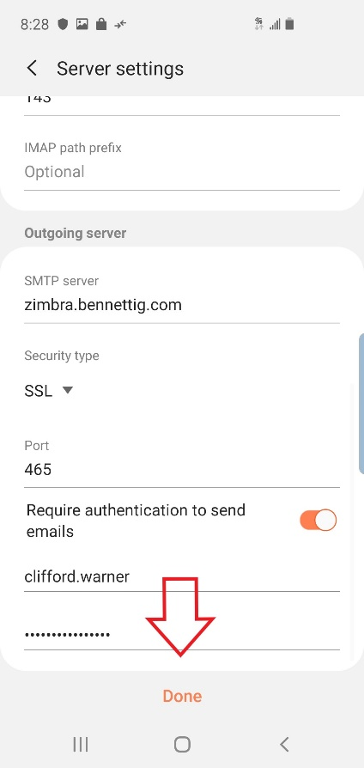
- At the bottom of the screen hit Done.

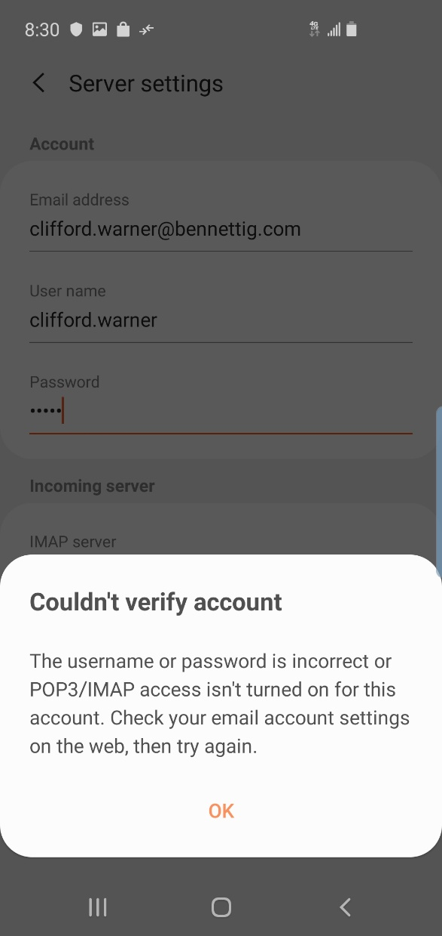
- If you do not get any errors, you are good. If you do get errors, check your password again.

- If you have any issues during this process, give Tech Support a call (18778307085).

