IPhone Email Password Change Instructions

1. 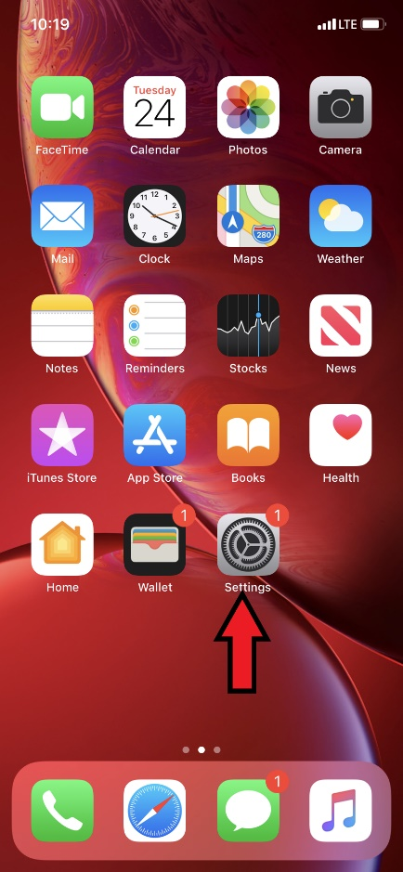Go to the **Settings App** on the phone (it’s the square with gears in it).
2. 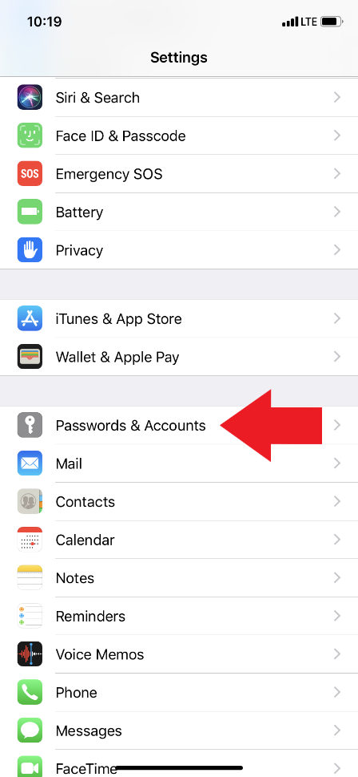Scroll down to where it says **Passwords & Accounts.**
3. 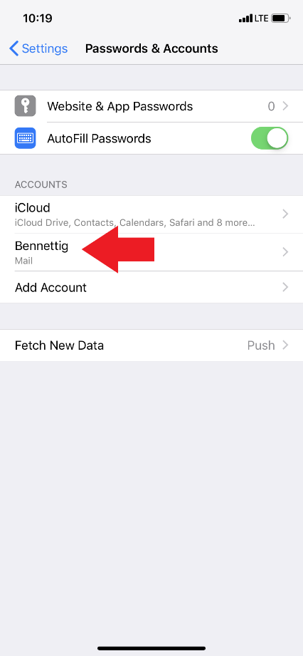Look for where it says either **Bennett,** **Zimbra mail,** or something similar to the prior (make sure it is the one that says mail below it).
4. 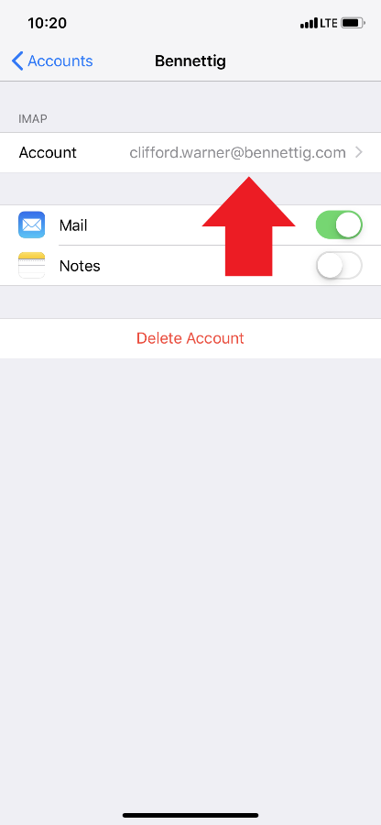Tap on where your email address is shown.
5. 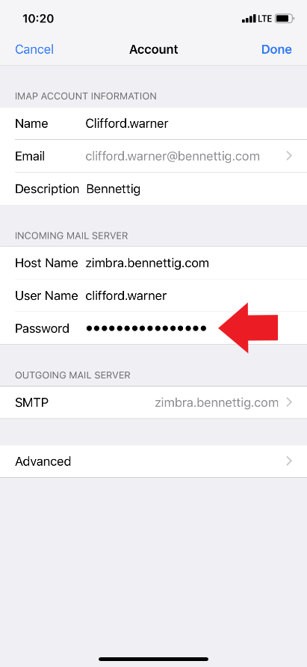In the first **Password Slot**, type in your new password.
6. 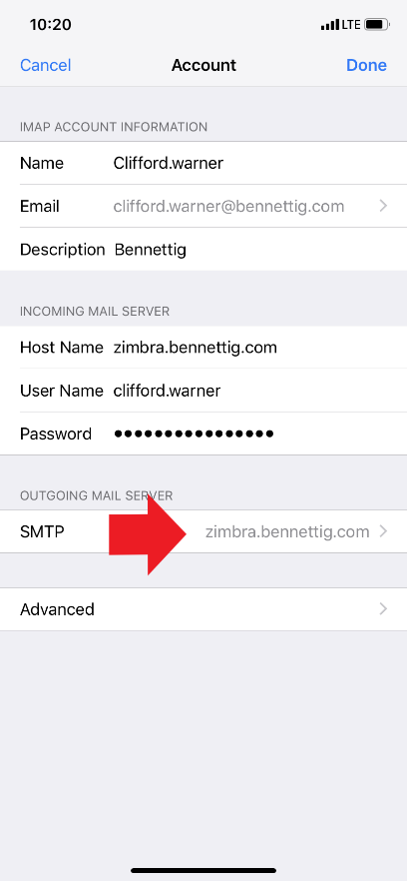Now look for the option that says **Outgoing Mail, or SMTP.** Tap on **SMTP**.
7. 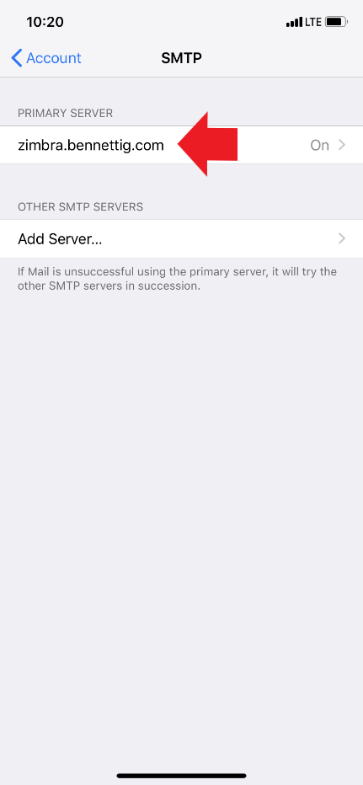Then, it will come up to a page that says **Zimbra.bennettig.com.** Tap on that.

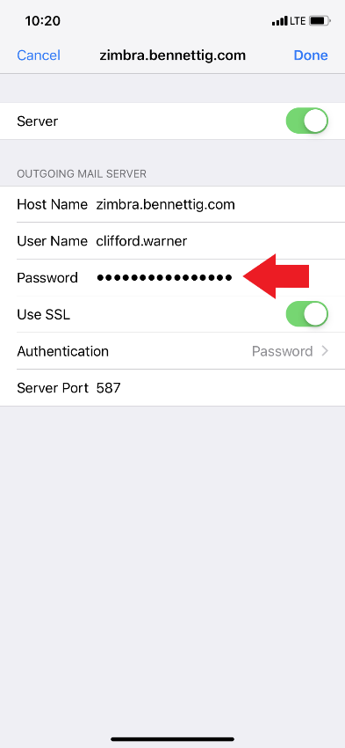

1. Now, it should come up with another **Password Slot.** Change the password there.
2. 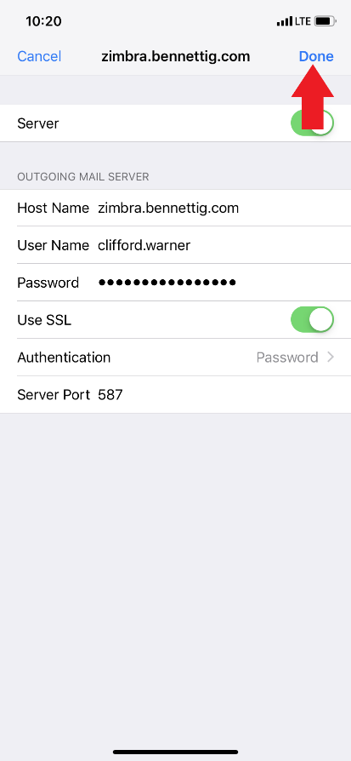Hit **Done** in the top right corner. If it kicks you back to the screen with **zimbra.bennettig.com**, go to the next step. If it doesn’t, check that you are typing the correct password.

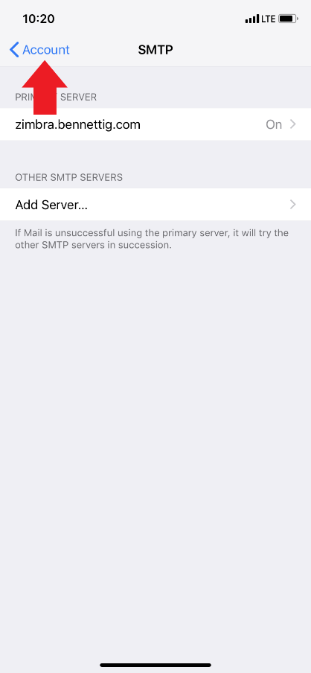

1. Now that you are at the screen that says **Zimbra.bennettig.com,** tap the **Account** button at the top right.
2. 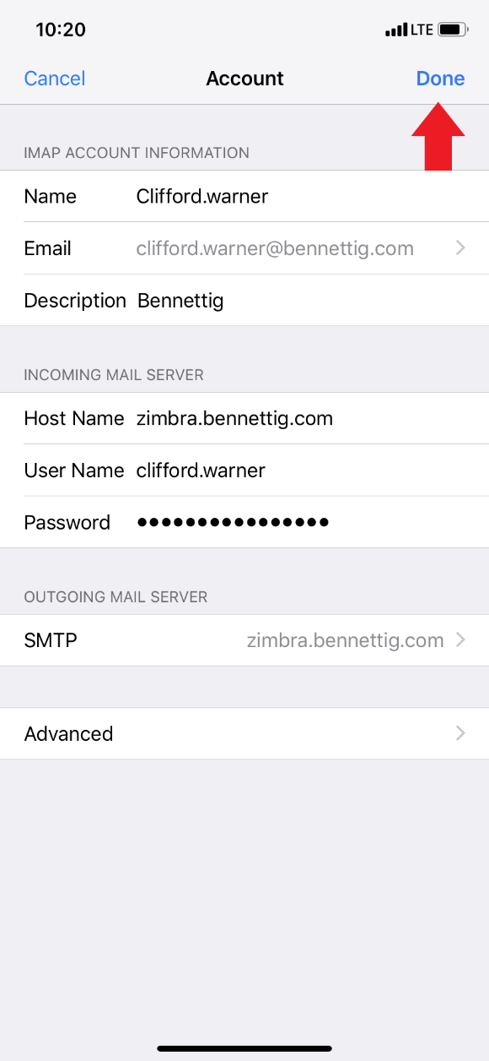Now you are at the page with the first the **Password Slot.** Hit **Done** at the top right. If it verifies and kicks you back to the screen with your email on it, you are good. If it gives you an error, check that you have typed the correct password in that slot.
3. If you see **CalDev** or **CardDev**, or both, in your accounts section, you will need to change the passwords in those spots as well.